

|  |
| --- |
| BUV – Stirling University |
| Tasty Loop — Interactive Cooking Hobby Website |
| 2410DSAI BUV |

|  |
| --- |
| Cuong Tran – 30065980  11-7-2025 |

Contents

Section 1 – Concept & Target Users 2

General concept and core idea 2

Purpose of the website 2

Why this is a strong design concept 2

Intended audience 2

Section 2 – Design Development 1

User Story 1 – Minh Tran 1

User Story 2 – Lan Nguyen 1

Customer Journey Map 2

Break The Purposes Down Into Requirements 3

Functional Requirement 3

User Flows 4

Wireframe 6

High Fidelity Prototype 16

Section 3 – Usability Testing & Evaluation 27

Heuristic Evaluation 27

Usability Testing Plan. 28

Section 4 – Group Activities & Co-Design 29

Usability Testing Results. 29

Section 5 – Prototype & Resources Description 31

References: 33

# Section 1 – Concept & Target Users

General concept and core idea  
Tasty Loop is an interactive cooking website that replaces static, text-heavy recipes with responsive, intuitive experiences. Instead of scrolling through long stories and fixed ingredient lists, users work with dynamic recipe cards that scale portions in real time, show step cues, and just-in-time guidance through a built-in Cooking Toolbox. A signature feature, the Flavor Mixer lets people combine ingredients virtually to explore pairings and suggested dishes, turning curiosity into a playful pathway for learning.

Purpose of the website  
The purpose of Tasty Loop is to make cooking approachable, enjoyable, and educational for hobbyists. It lowers the barrier to entry by guiding users visually and interactively rather than expecting them to interpret large amounts of information.

Why this is a strong design concept  
By using interactive tools and multimedia, Tasty Loop keeps users engaged and supports learning by doing. The layout follows good web-design and UX principles such as clarity, consistency, and quick feedback. It works well on both phones and computers using Bootstrap 5. The concept is strong because it is user centered, the site addresses well-known pain points in existing cooking sites: cognitive overload, poor flow between steps, and limited support for improvisation.

Intended audience  
Tasty Loop is aimed at adolescents, students, and young professionals or young families who treat cooking as a hobby or creative outlet rather than a professional craft. These users prefer quick comprehension, mobile-friendly layouts, and immediate feedback.

Vietnam’s demographic and digital profile makes this audience both sizable and reachable: the median age is ~33 years, and internet user identities and social-media reach already cover most adults (DataReportal, 2024).Many have limited time, small kitchens, or tight budgets; they are motivated by convenience and exploration, not perfection.

The site also speaks to culturally curious users who enjoy learning the “why” behind ingredients and techniques, including a Vietnamese audience interested in global flavours and an international audience discovering Vietnamese and regional dishes. For a culturally curious segment—Vietnamese exploring global flavours and international users discovering Vietnamese dishes—the interface’s visual, mobile-native flow and quick feedback loops align with how Vietnamese discover food content online (Decision Lab, 2024).

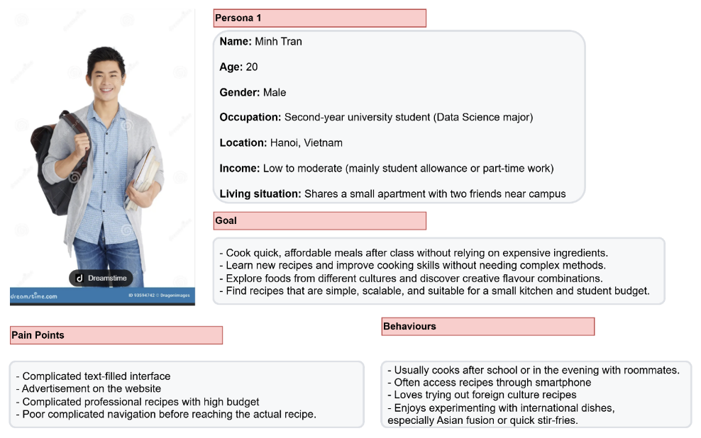

Figure 1 Minh the Student

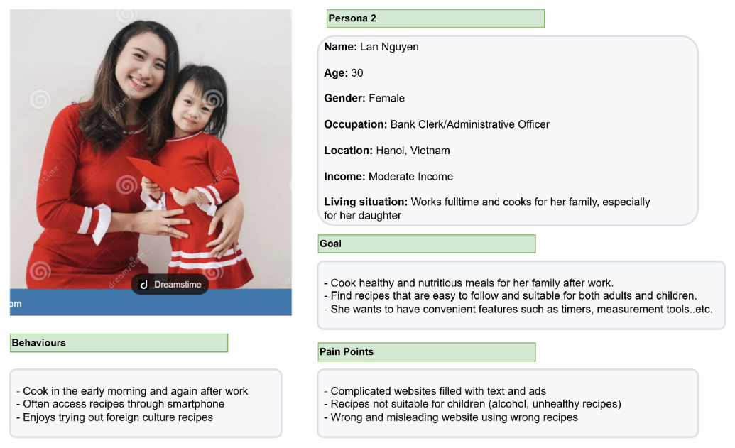

Figure 2 Lan The Family Mother

## Section 2 – Design Development

### User Story 1 – Minh Tran

|  |  |  |  |
| --- | --- | --- | --- |
| **Type of user (role)** | **Goal / Desire** | **So that I can** | **Motivation / Benefit** |
| As a time-pressed student, I want to… | find quick 15–20 minute recipes filtered by time and cost | cook a simple meal after class without wasting time | save time and money while learning to cook |
| As a student cooking for one or two, I want to… | adjust portion sizes with a slider | make the right amount of food | reduce waste and avoid extra shopping |
| As a multi-tasking cook, I want to… | follow large, step-by-step recipe cards with an auto-advance timer | keep cooking without touching my device | cook safely and hands-free |

### 

### User Story 2 – Lan Nguyen

|  |  |  |  |
| --- | --- | --- | --- |
| **Type of user (role)** | **Goal / Desire** | **So that I can** | **Motivation / Benefit** |
| As a parent managing many tasks, I want to… | open a website with timer, converter, and substitutes | adapt recipes easily while cooking | stay organized and keep cooking smooth |
| As a flavour explorer, I want to… | mix ingredients in the and get suggested recipes | discover creative dishes with what I already have | learn new combinations and reduce food waste |
| As a home cook, I want to… | use a compact Recipe Card interface with big buttons and clear steps | follow recipes using one hand on my phone | cook more safely and conveniently while multitasking |

Figure 3 User Story 2 Lan Nguyen

### A screenshot of a computer AI-generated content may be incorrect.Customer Journey Map

Figure 4 Customer Journey Map

### 

### Break The Purposes Down Into Requirements

The Tasty Loop prototype follows User-Centred Design (UCD) principles—iterating from user needs to requirements, design solutions, and evaluations—to keep the interface intuitive and accessible (ISO 9241-210, 2019; Norman, 2013). Based on these frameworks and data from personas, we compiled the structured tables below to make design assets, page functions.

|  |  |
| --- | --- |
| Primary Requirement | Secondary Requirement |
| Both users need easy navigation and quick access to recipes. | Lan wants integrated cooking tools such as timer, converter…etc. |
| Both users need to adjust portions based on their demands. | Both users want the site to be optimized for mobile use. |
| Both users needs interactive simple recipes | Both Users expect a consistent layout and icons across all pages. |
|  | Both want accessibility across devices and screen sizes. |

Figure 5 Primary & Secondary Features

### Functional Requirement

|  |  |
| --- | --- |
| Function | Description |
| Interactive Recipe Cards | Users can view each recipe as a step-by-step interactive card so they can follow instructions easily while cooking without scrolling long text. |
| Portion Scaling | Users can adjust the serving size using a portion button so that ingredient quantities automatically update to match their needs. |
| Flavor Mixer | Users can select and mix ingredients virtually to discover suitable pairings and creative dish ideas. |
| Toolbox | Users can access Toolbox which includes integrated mini functions such as converter, timer, substitute, shopping list. |
| Concise Steps View | Users can toggle between detailed and concise recipe instructions for faster in-kitchen reference. |
| Recipe Search and Filter | Users can filter recipes by categories, country, using search and dropdown filters. |

Figure 6 Required Function.

### User Flows

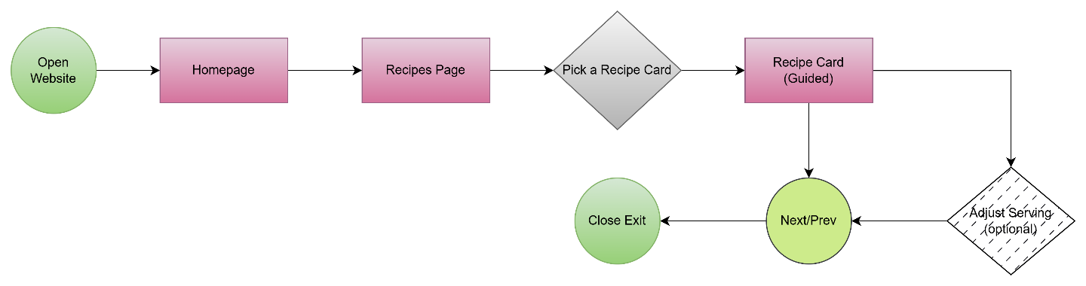

Figure 7 Recipes Card Interaction Flow

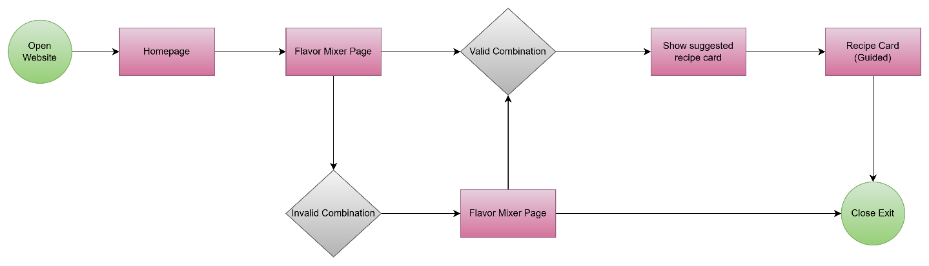

Figure 8 Flavor Mixer usage

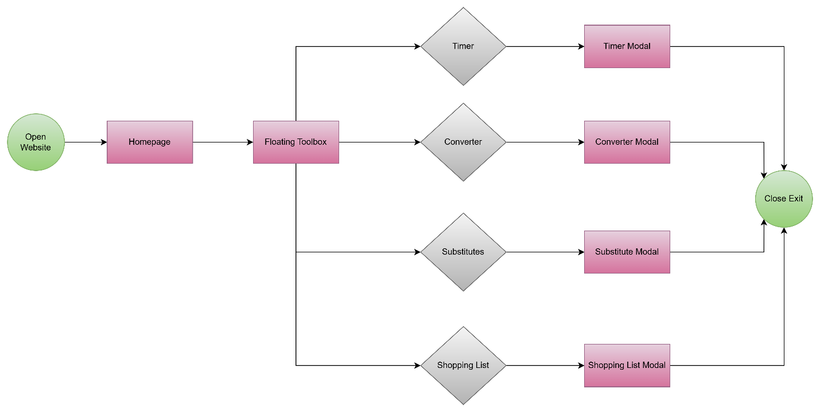

Figure 9 Toolbox Function

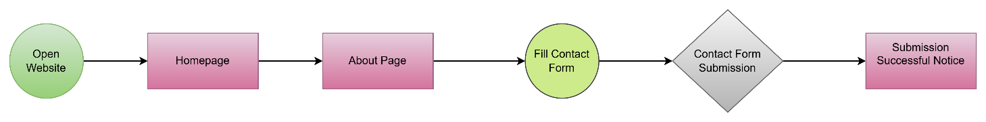

Figure 10 Contact Us Interaction

### Wireframe

The low-fidelity wireframes for the Taste Loop website were created using the Figma design platform. A community wireframe kit titled “Webby Wireframe” was utilised as the foundational resource for developing both the low-fidelity and high-fidelity prototypes. The kit’s modular components were adapted to define the website’s structural layout, navigation hierarchy, and interaction flow prior to visual refinement. During this stage, the primary emphasis was placed on functionality, usability, and task clarity, rather than on detailed aesthetics or colour design.

*Figma Community – Webby Wireframe:* <https://www.figma.com/community/file/1221009141145444839>

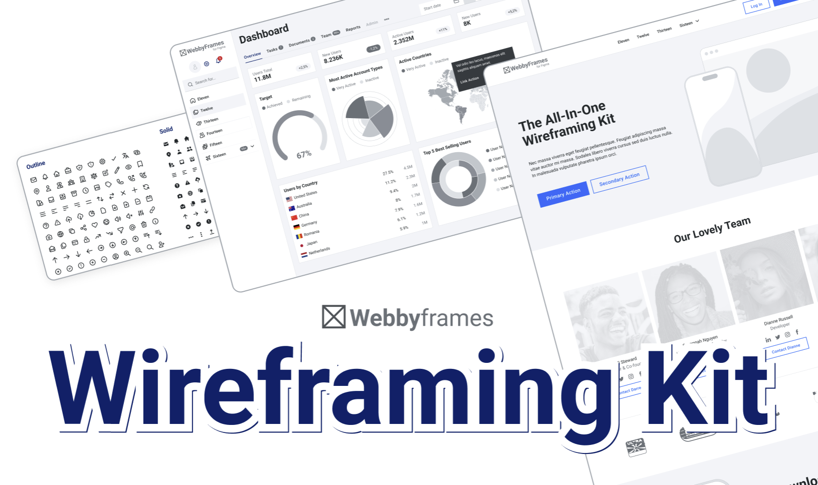

Figure 11 Wireframing Kits (Figma)

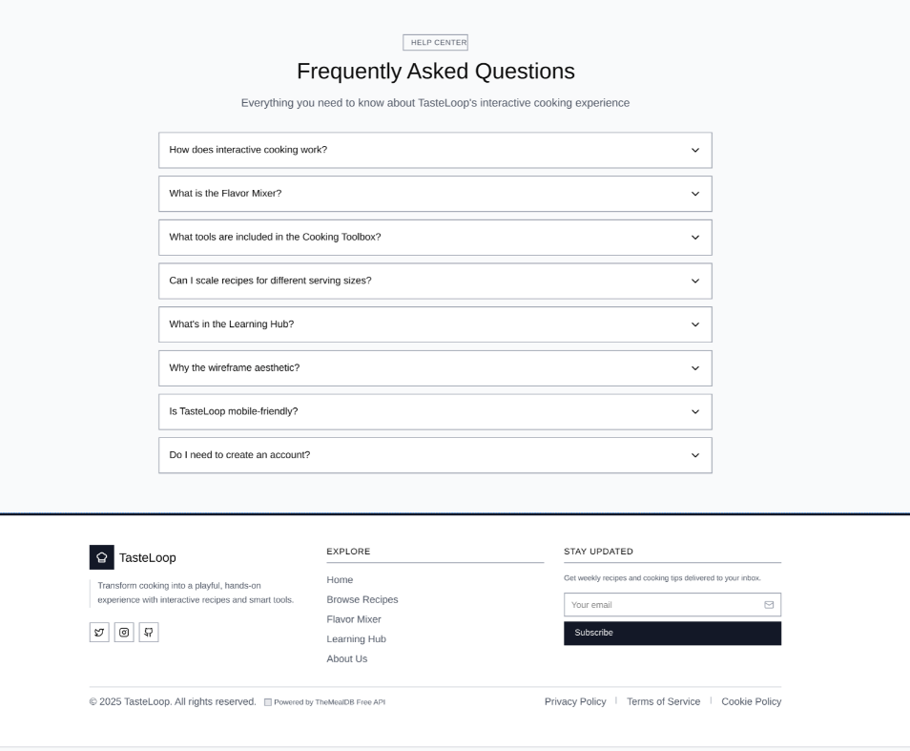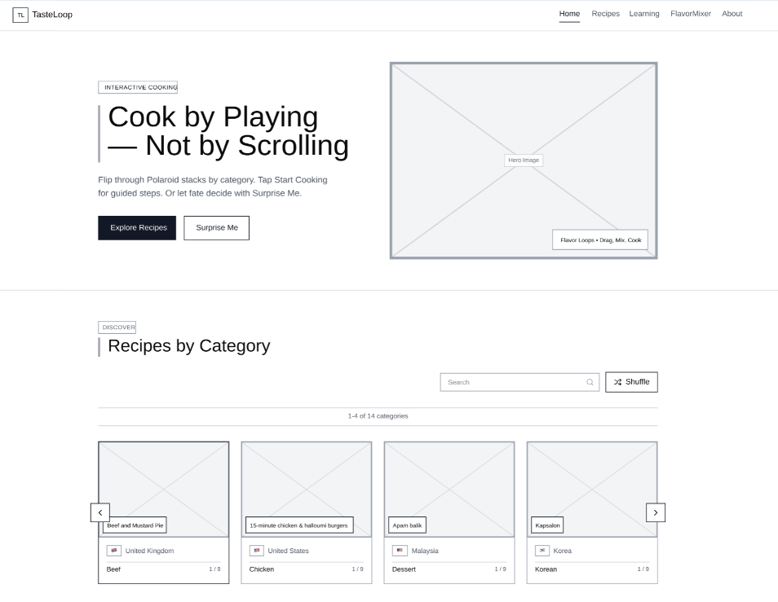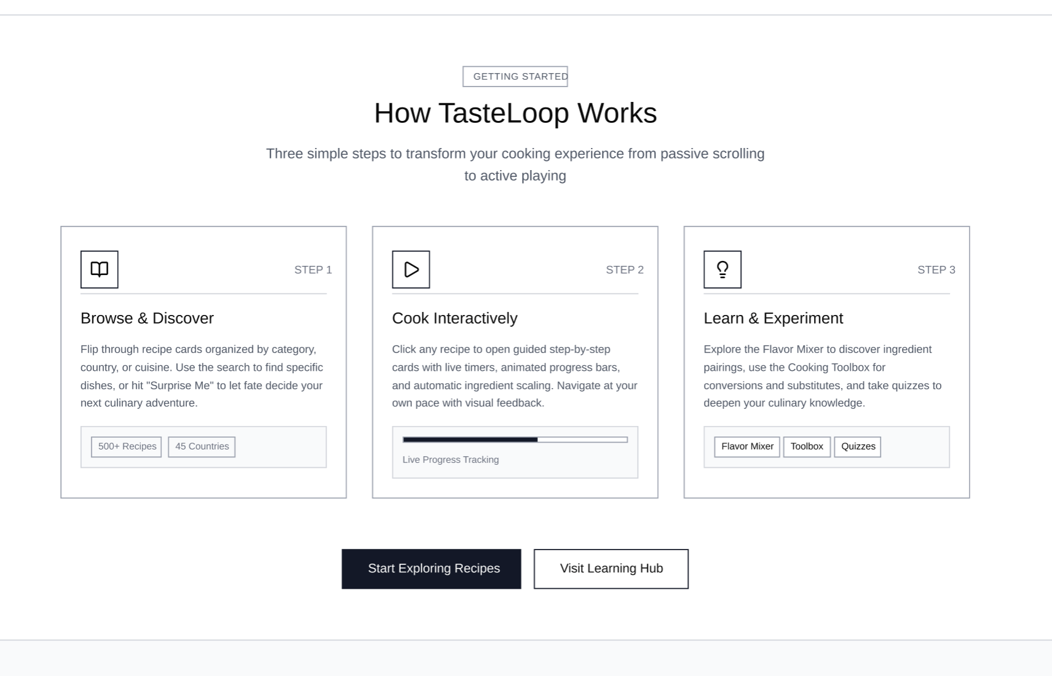

Figure 12 Homepage

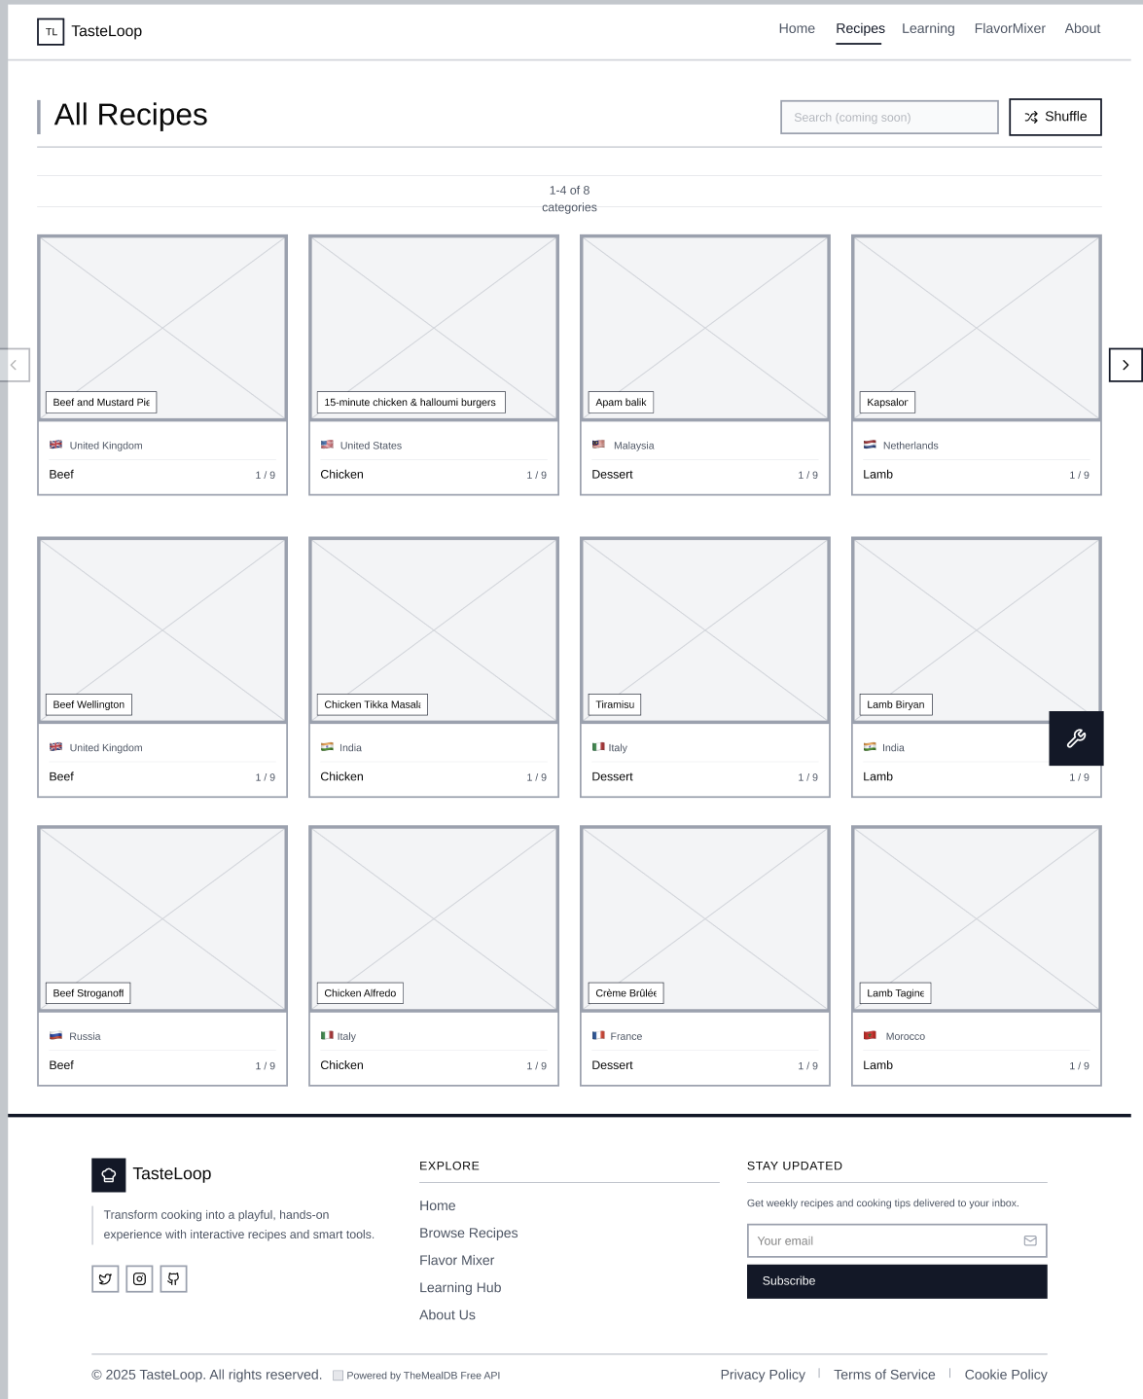

Figure 13 Recipe Page

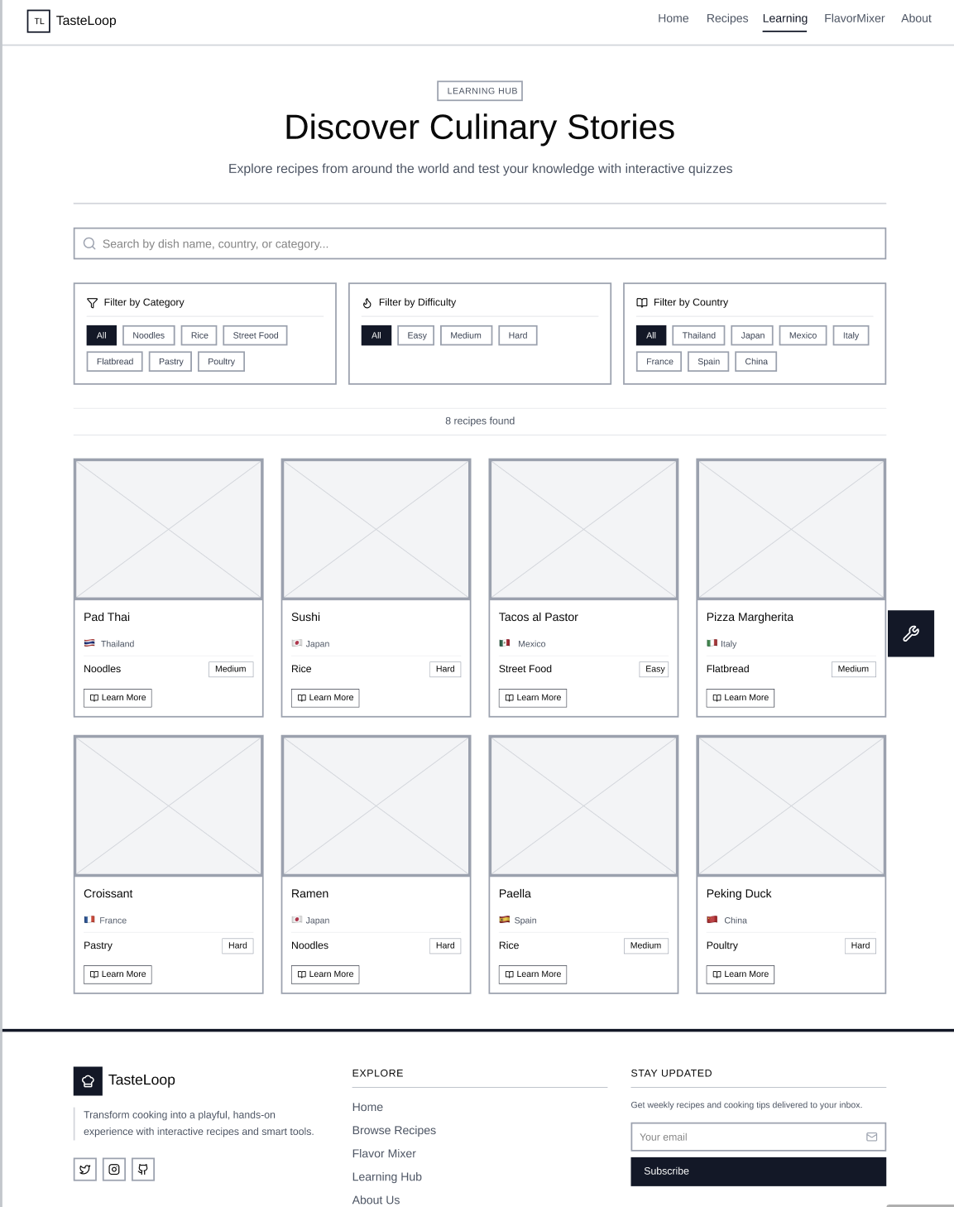

Figure 14 Learning Page

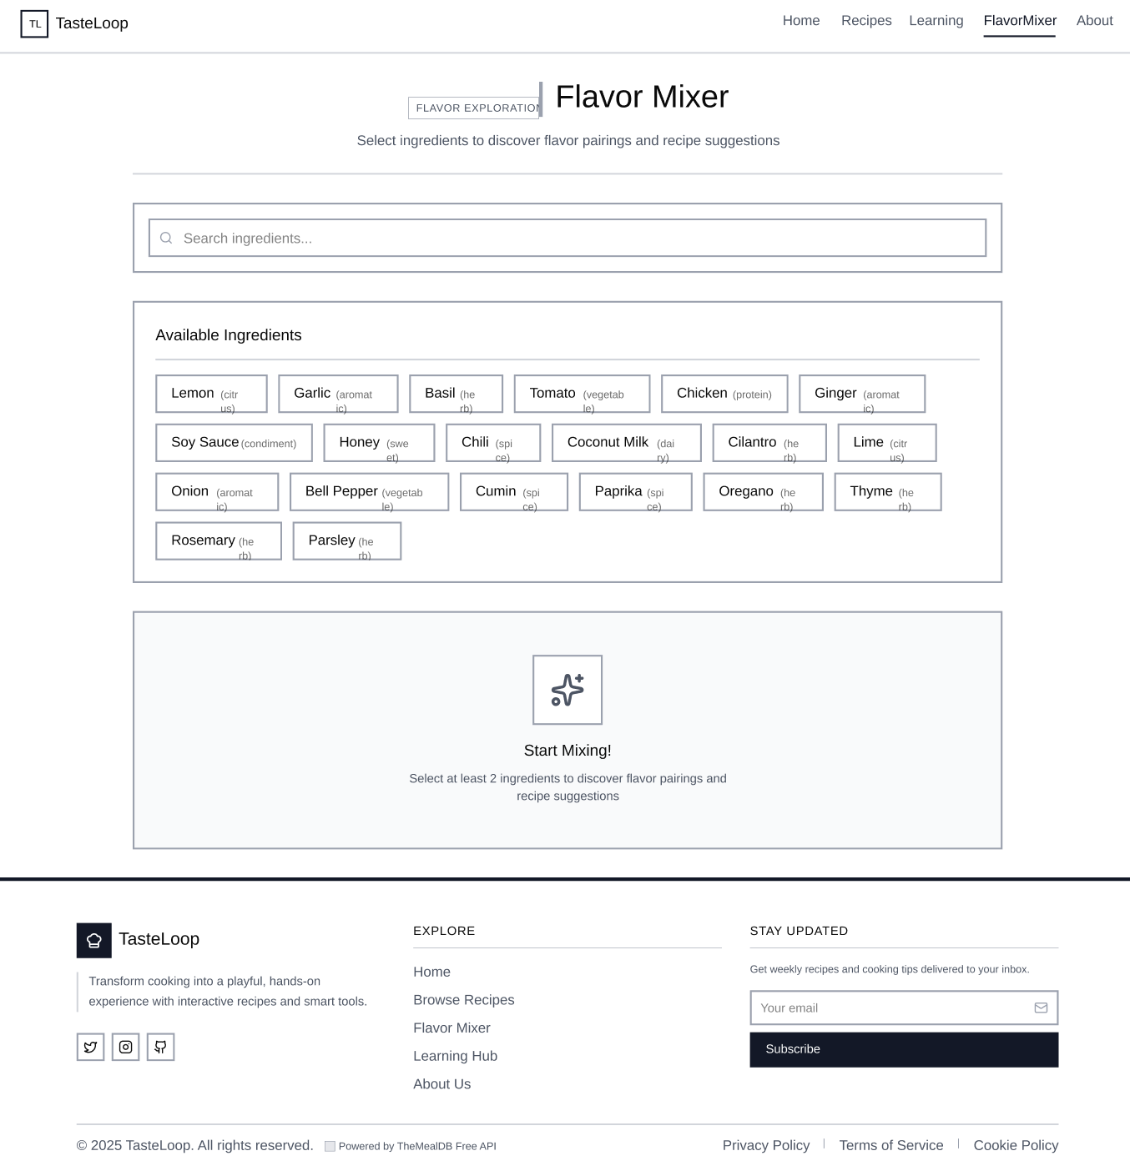

Figure 15 Flavor Mixer Page

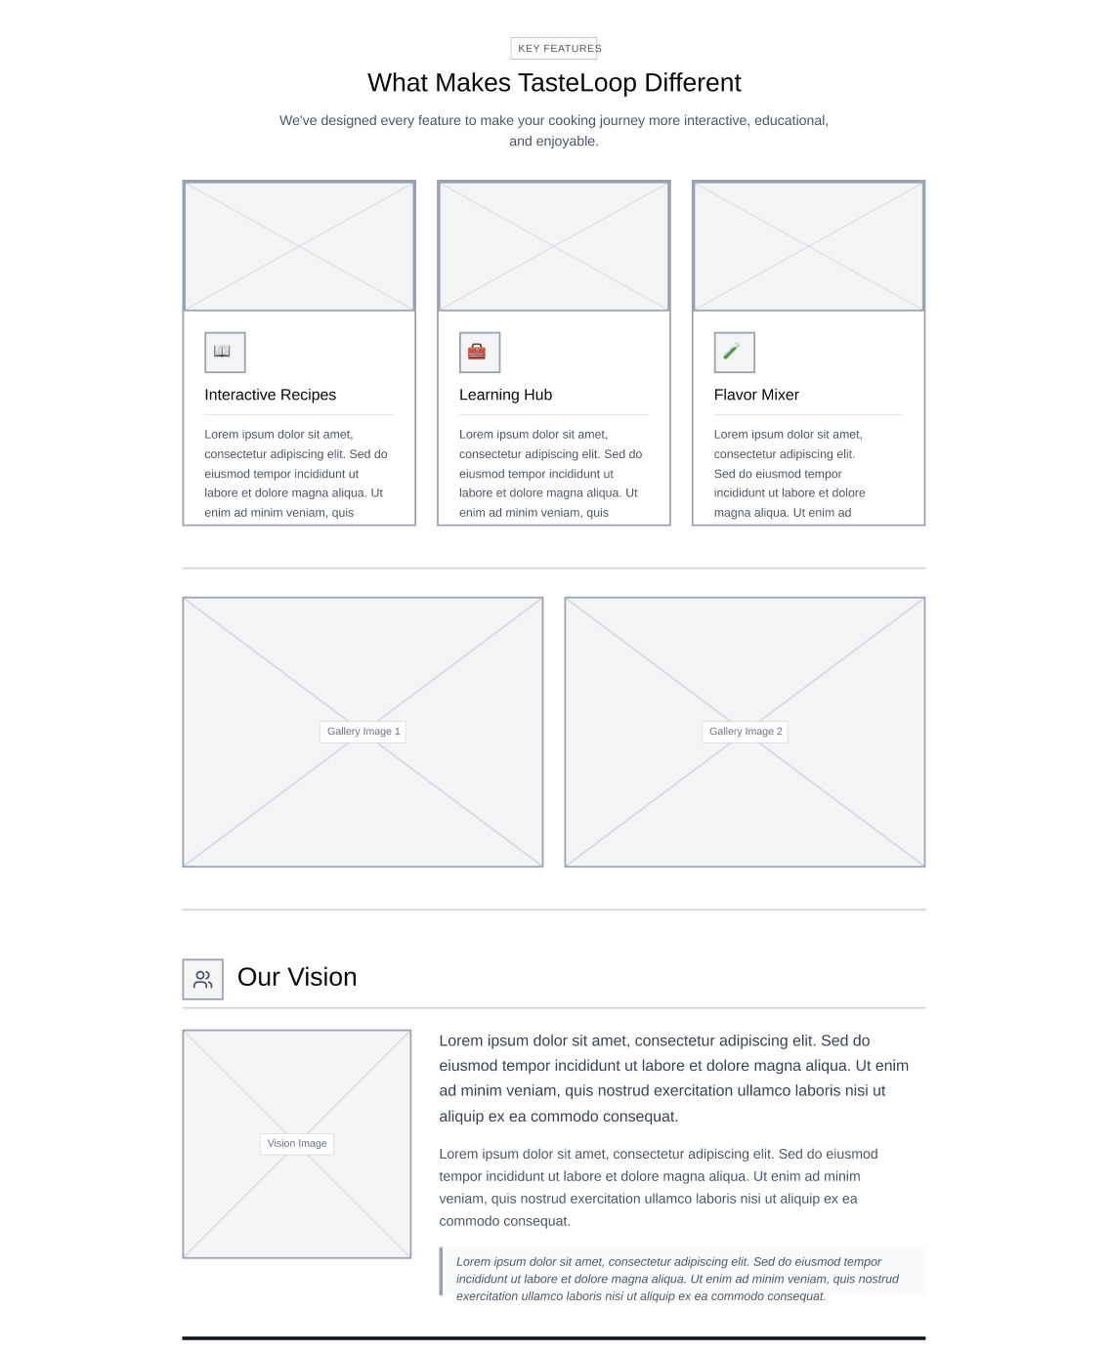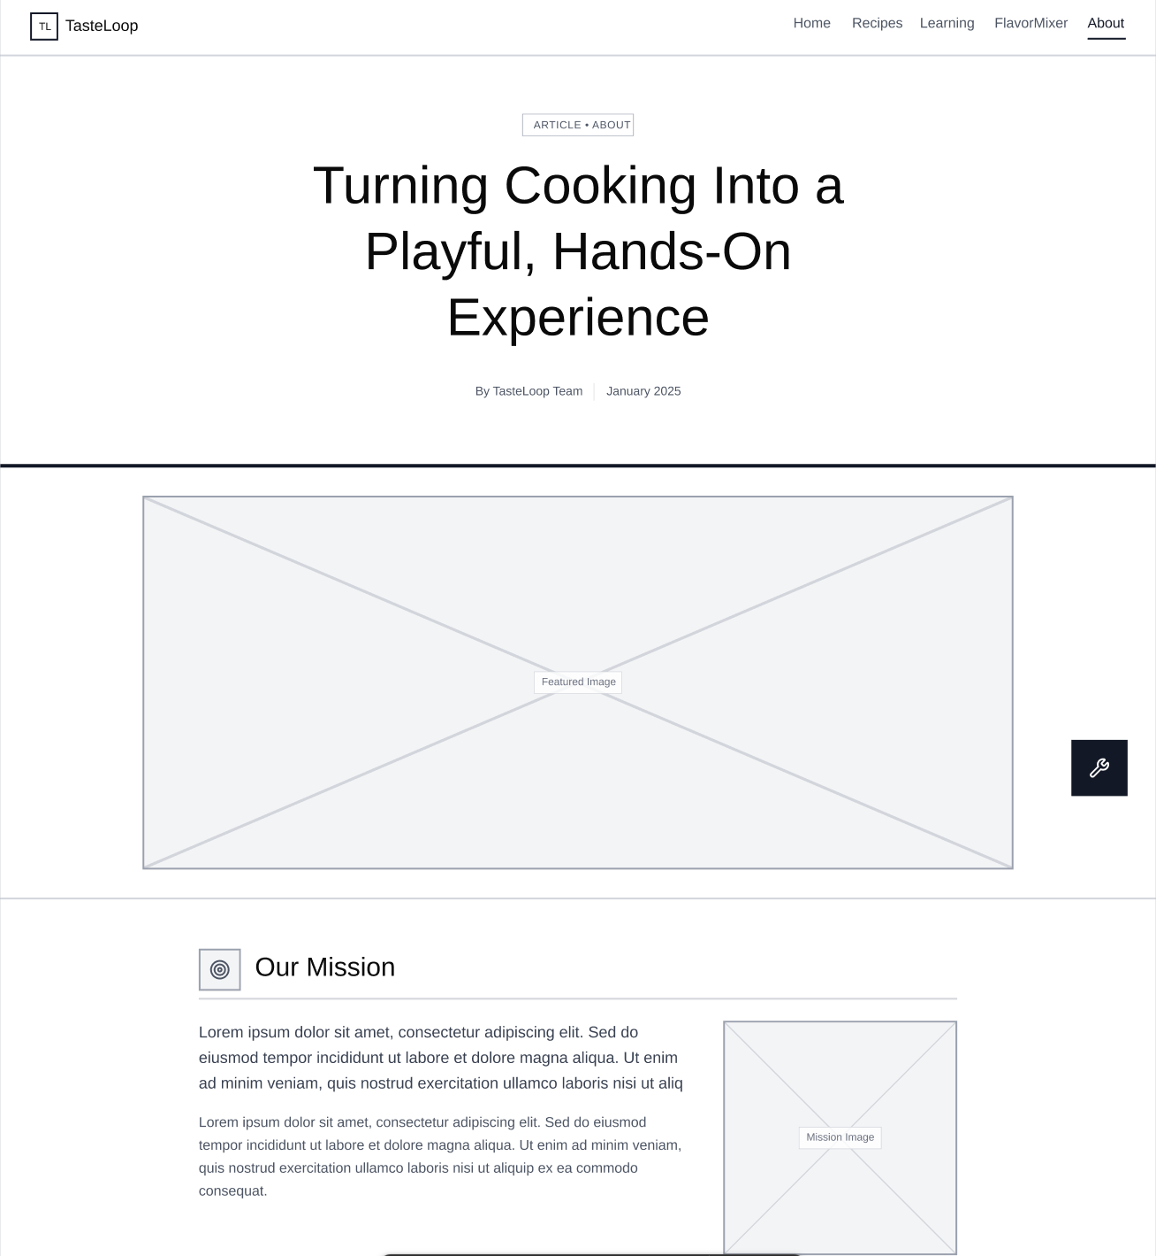

Figure 16 About Page

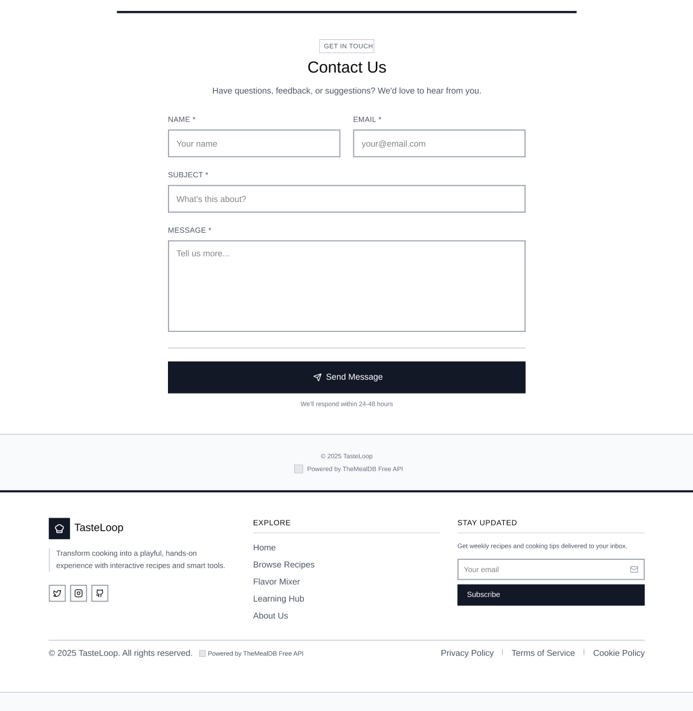

Figure 17 About Page 2

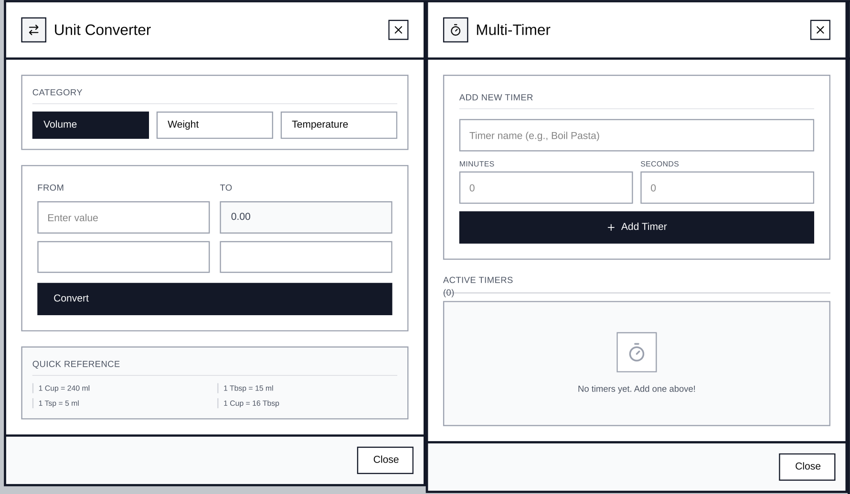

Figure 18 Converter & MultiTimer Function

Figure 19 Substitutes & Shopping list Function

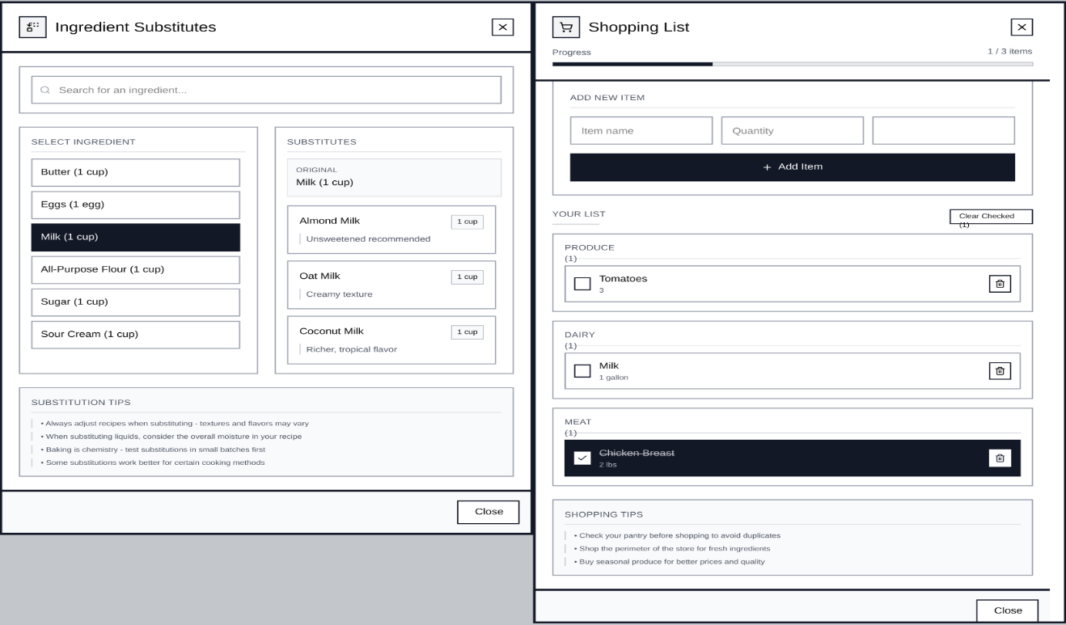

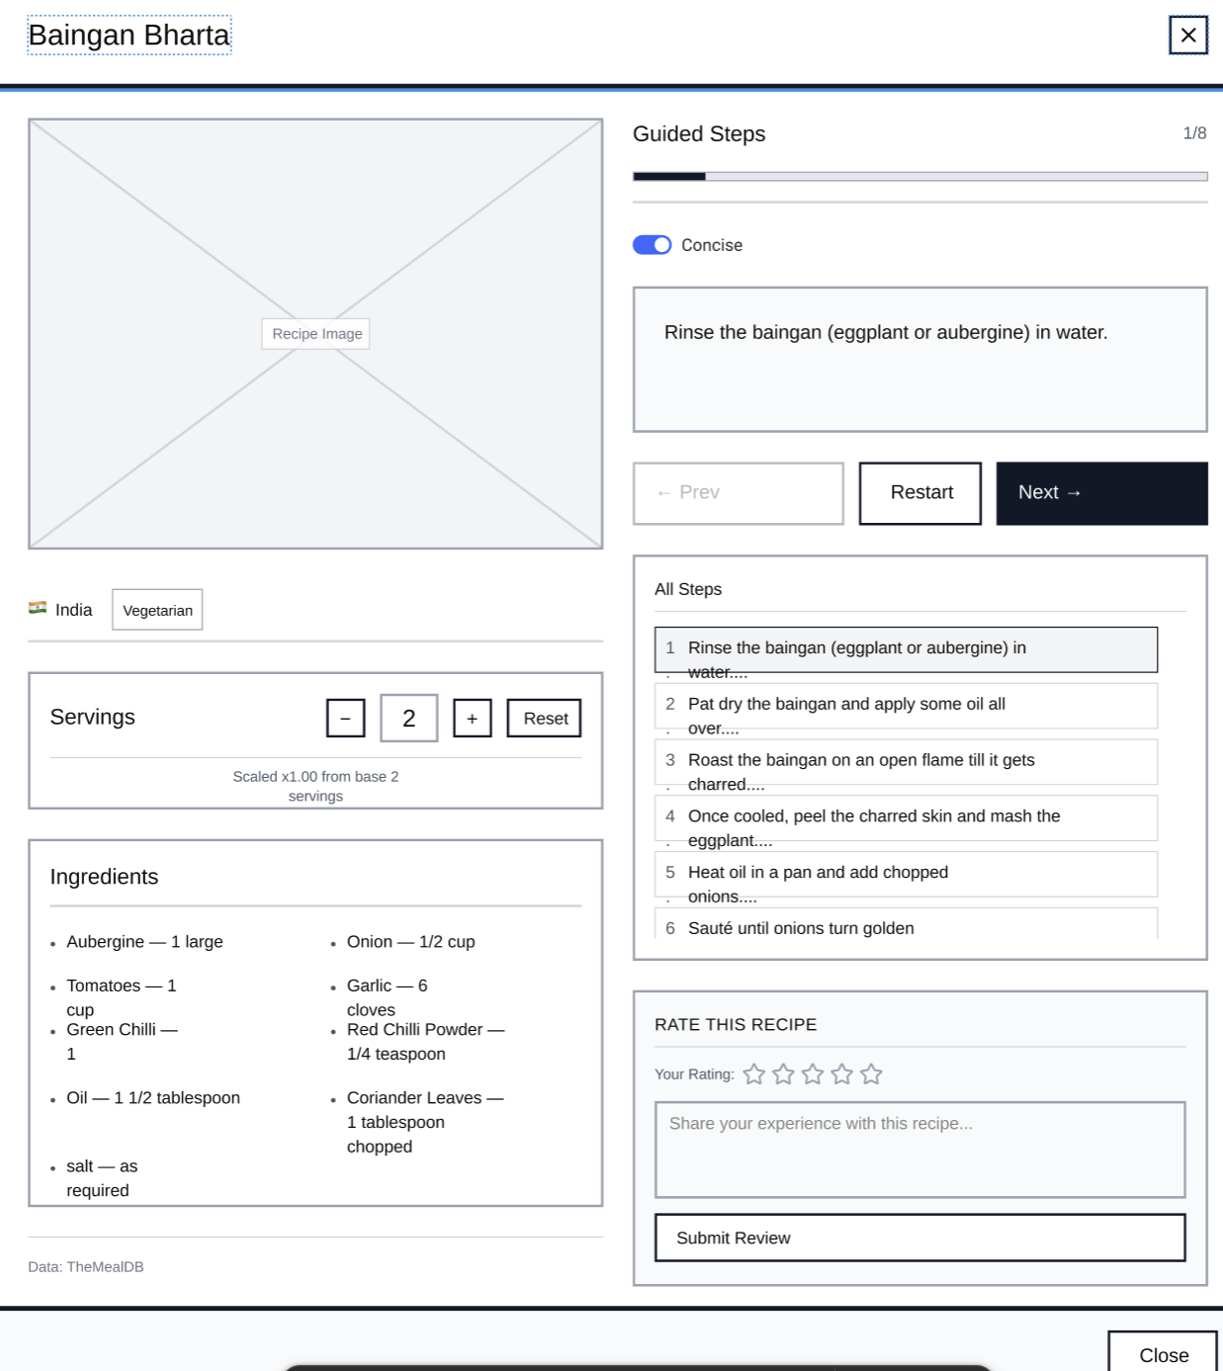

Figure 20 Recipe Card

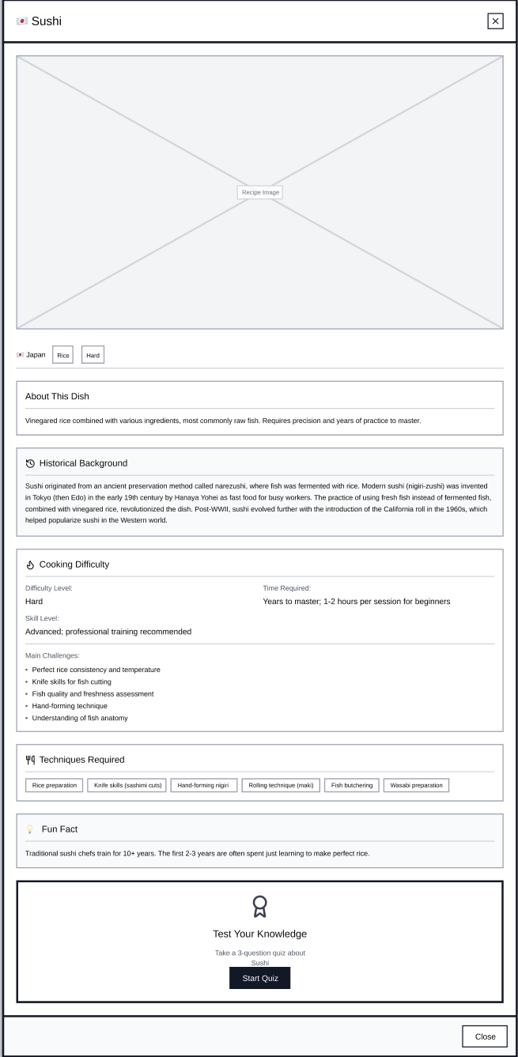

Figure 21 Learning Card

### High Fidelity Prototype

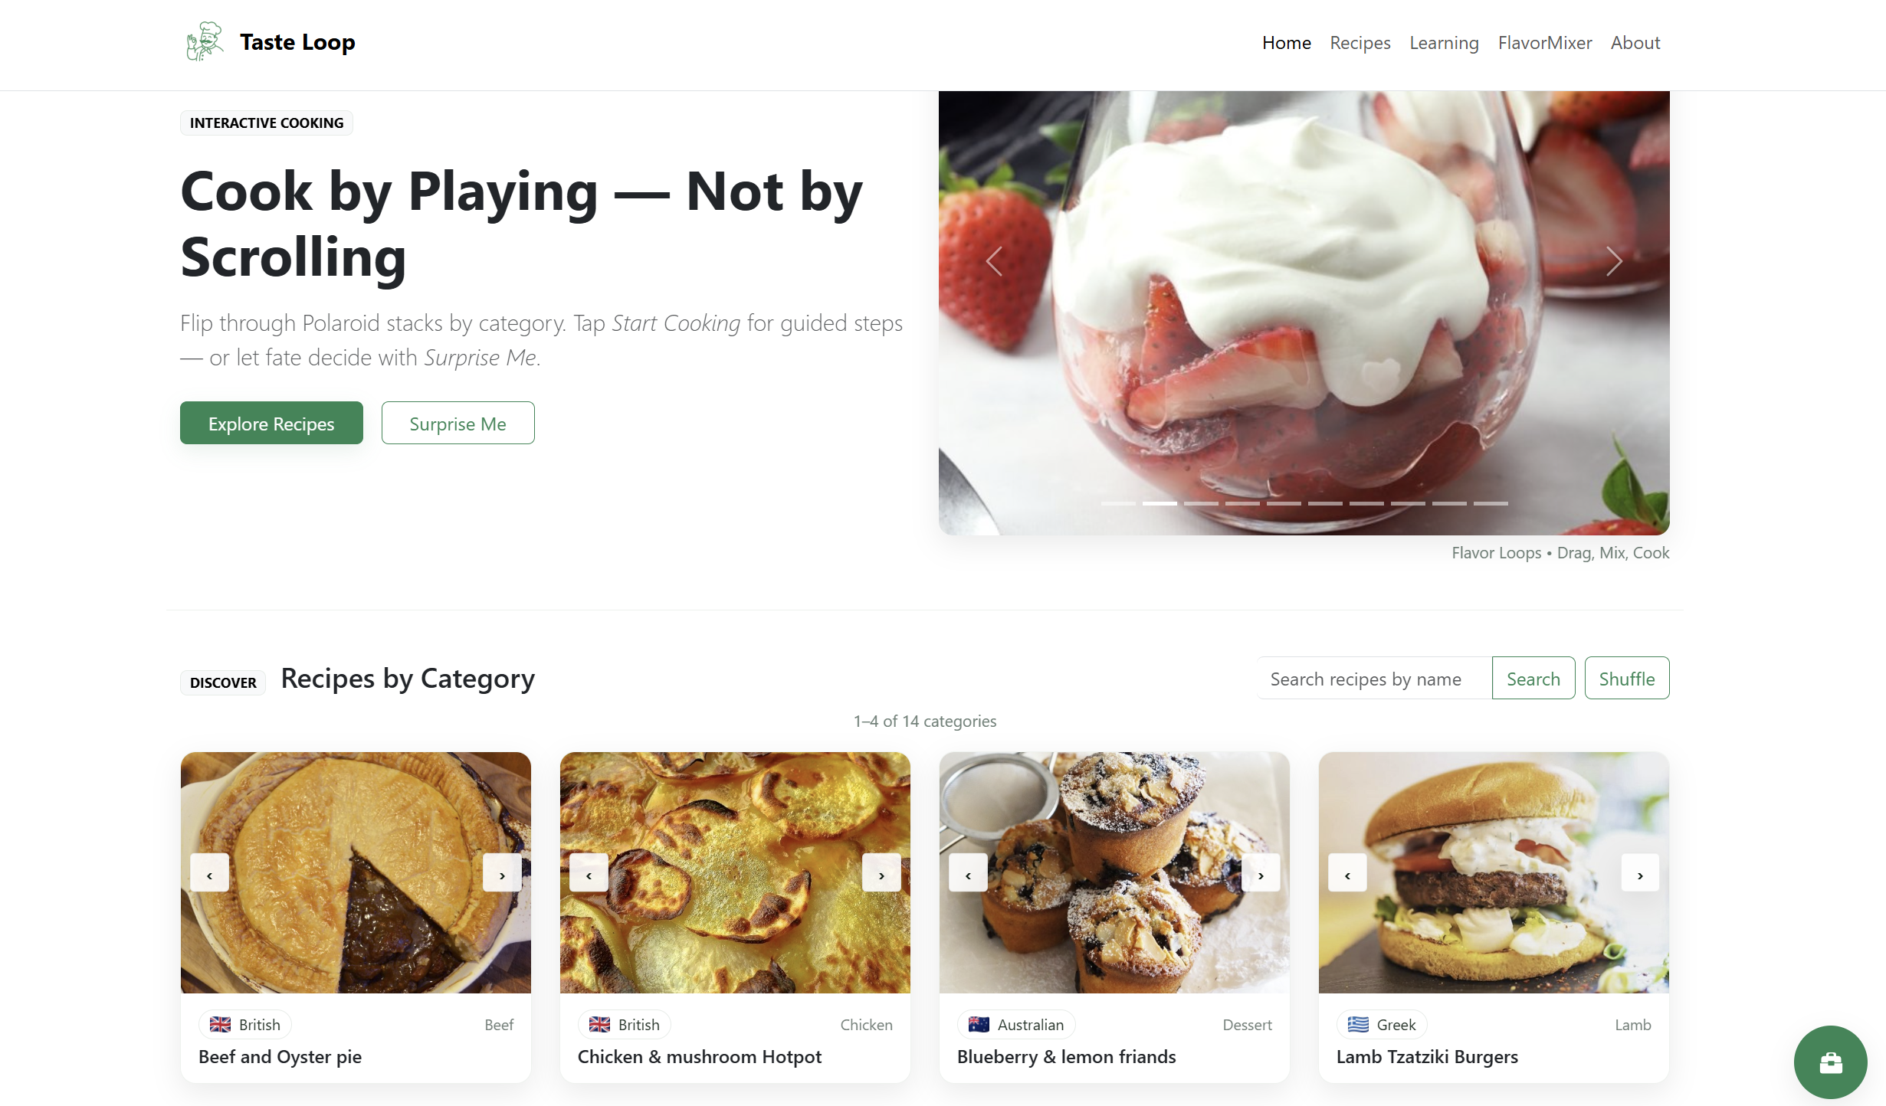

Figure 22 Homepage.

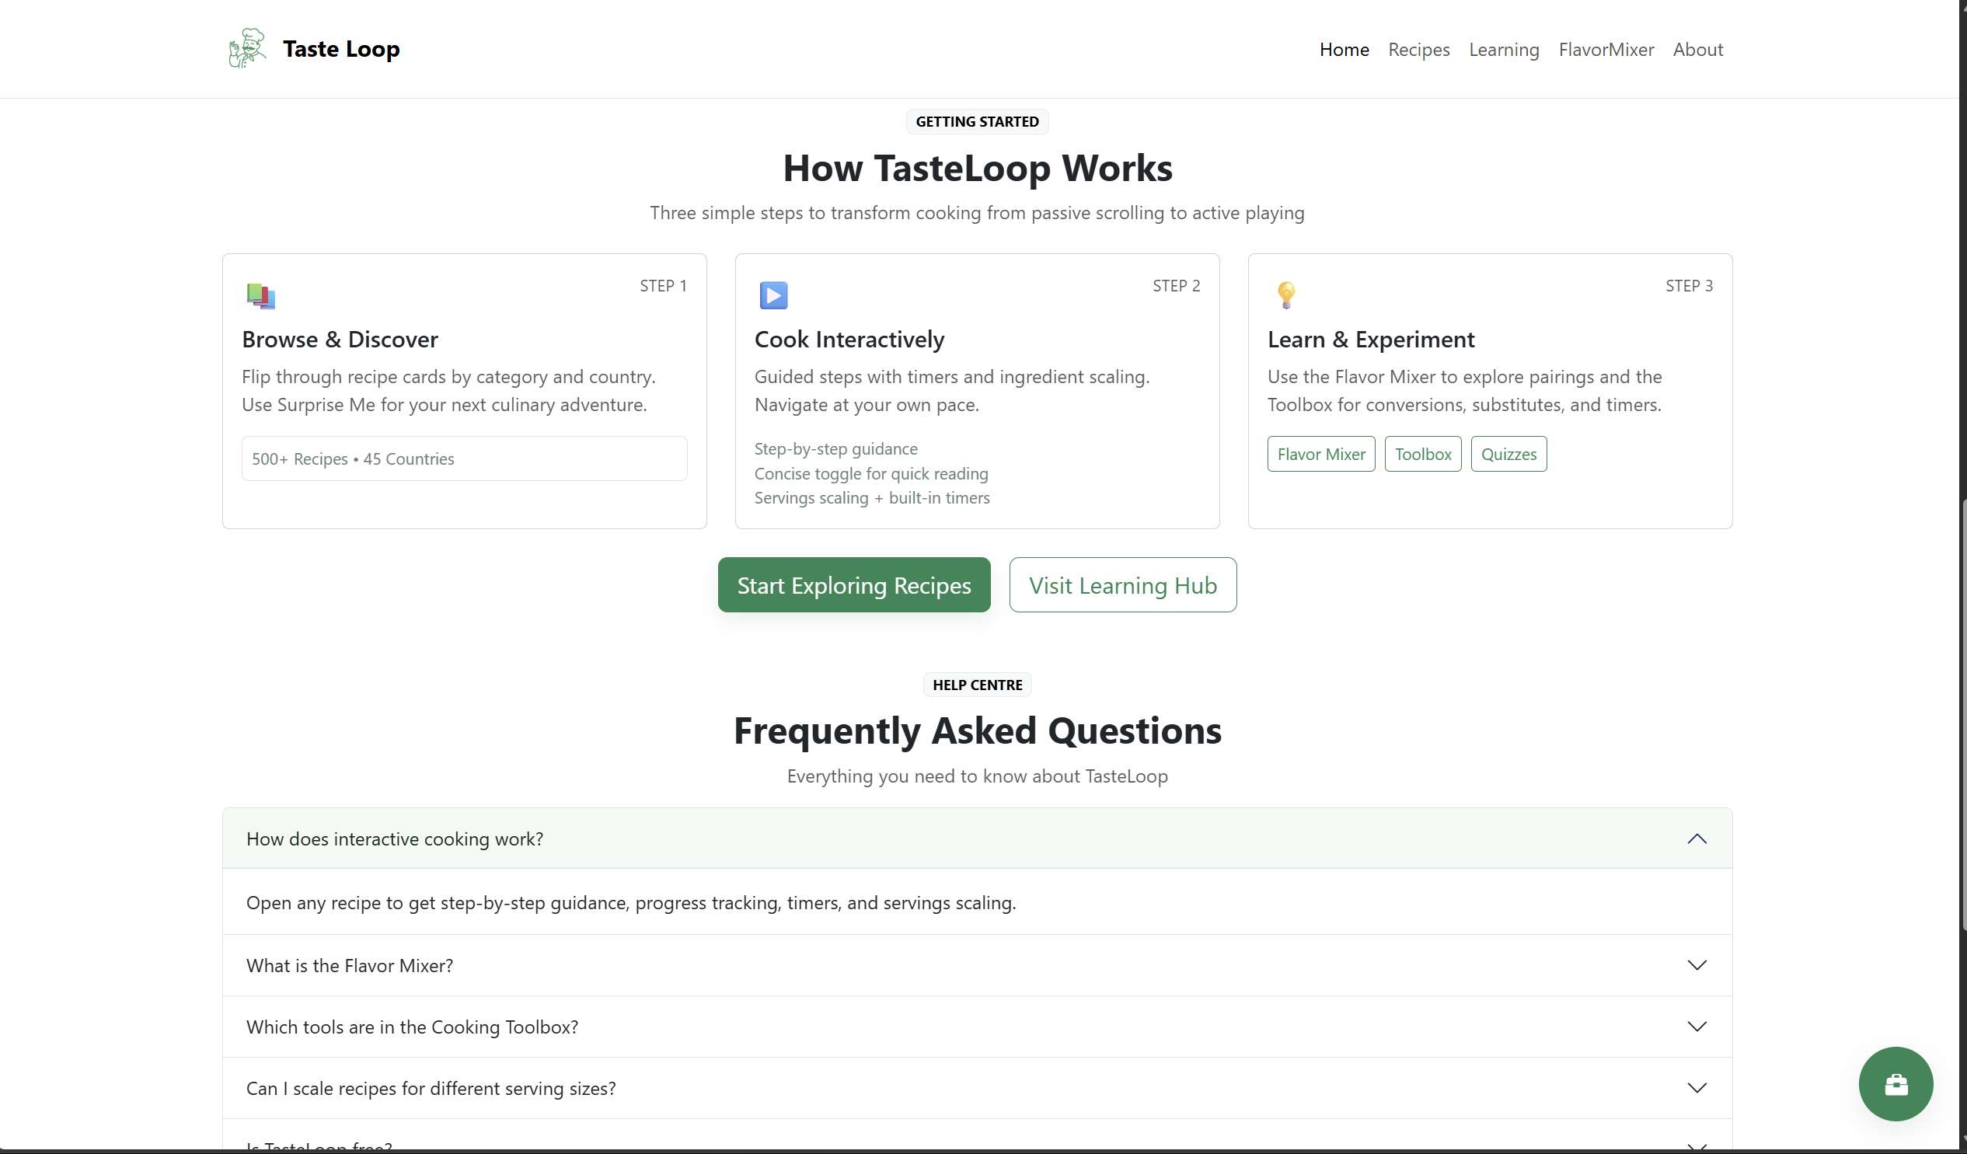

Figure 23 Homepage 2

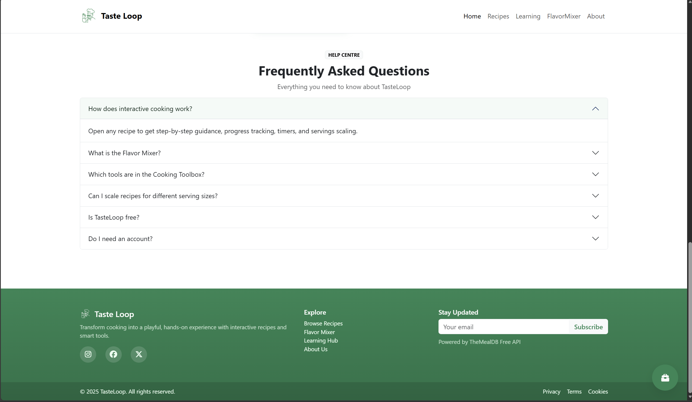

Figure 24 Homepage 3

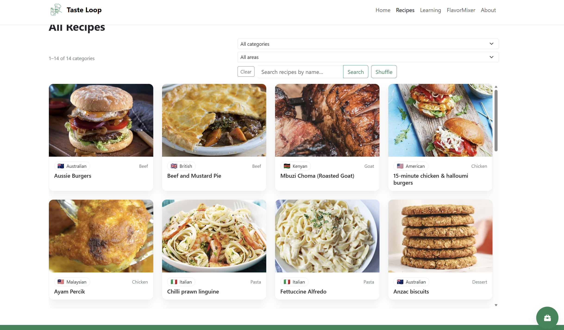

Figure 25 All Recipe Page

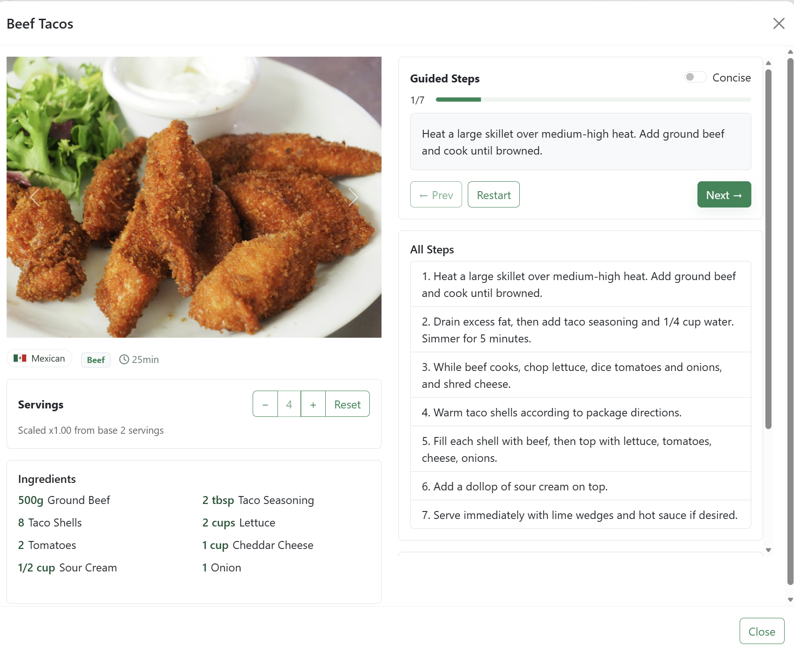

Figure 26 Recipe Modal

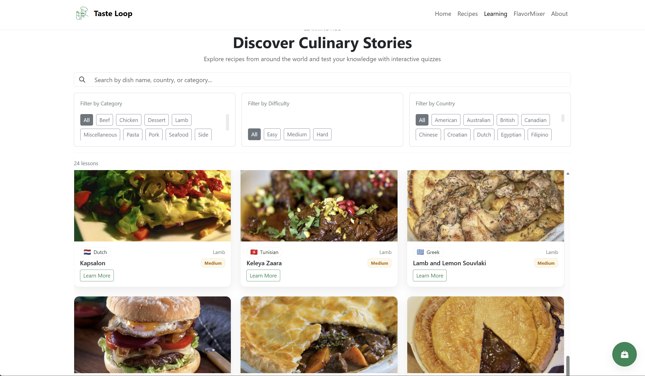

Figure 27 Learning Page 1

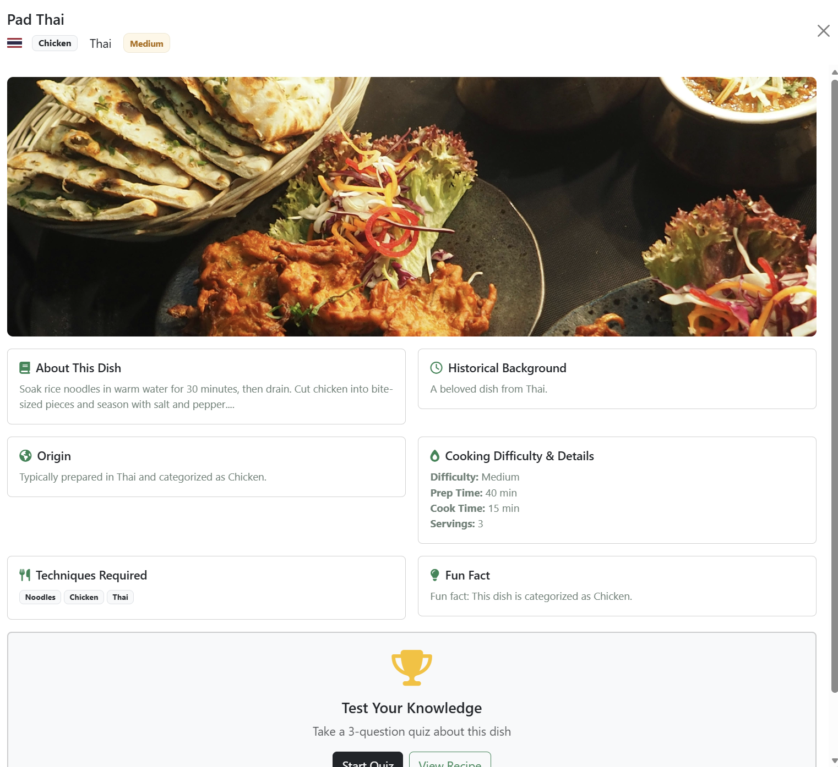

Figure 28 Learning Modal

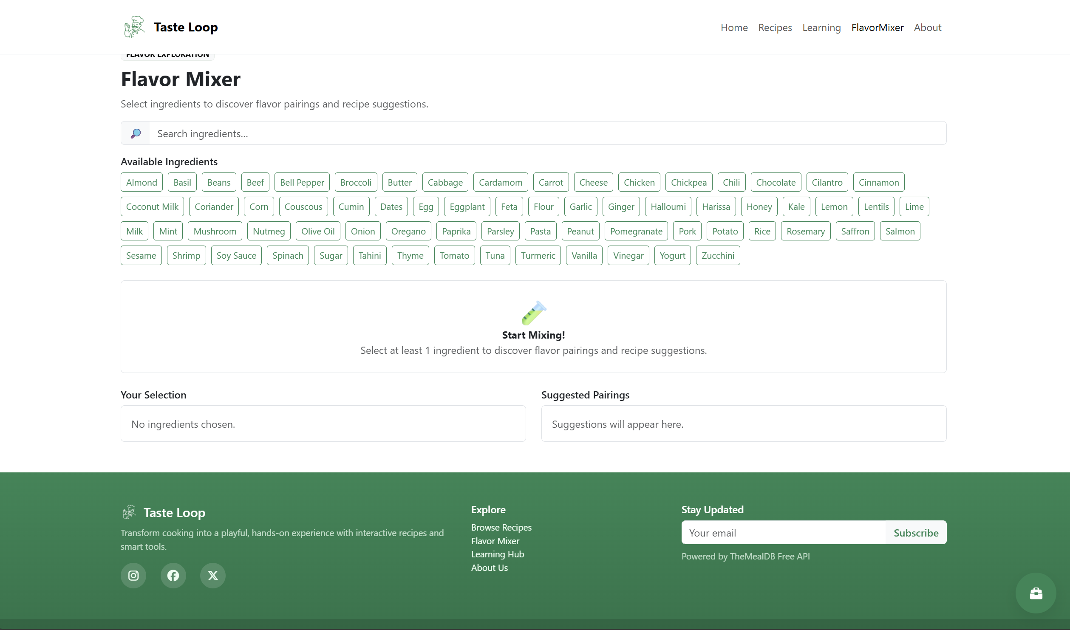

Figure 29 Flavor Mixer Page

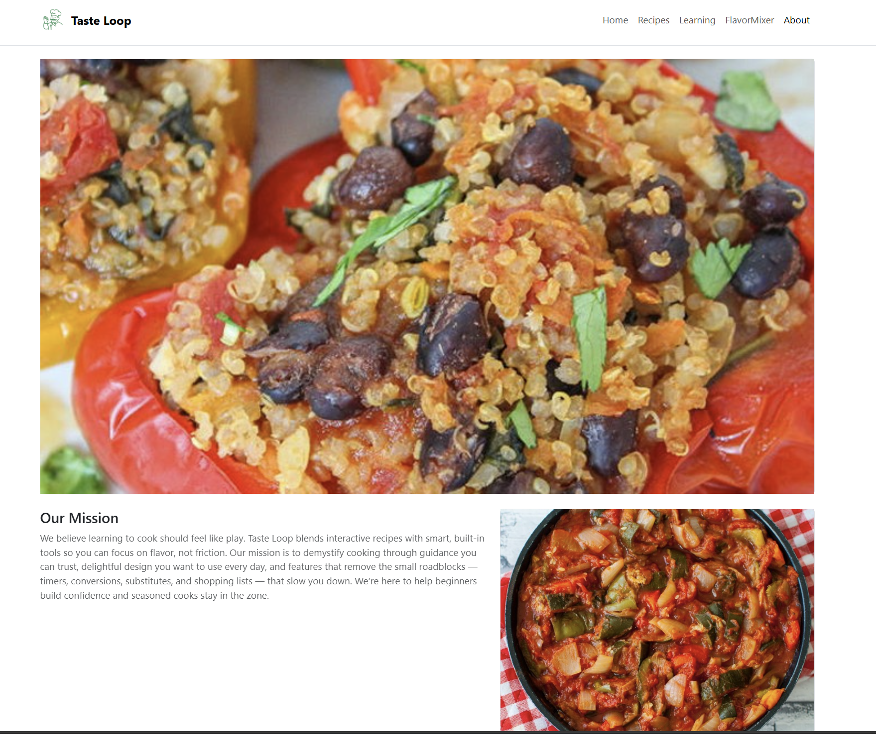

Figure 30 About Page 1

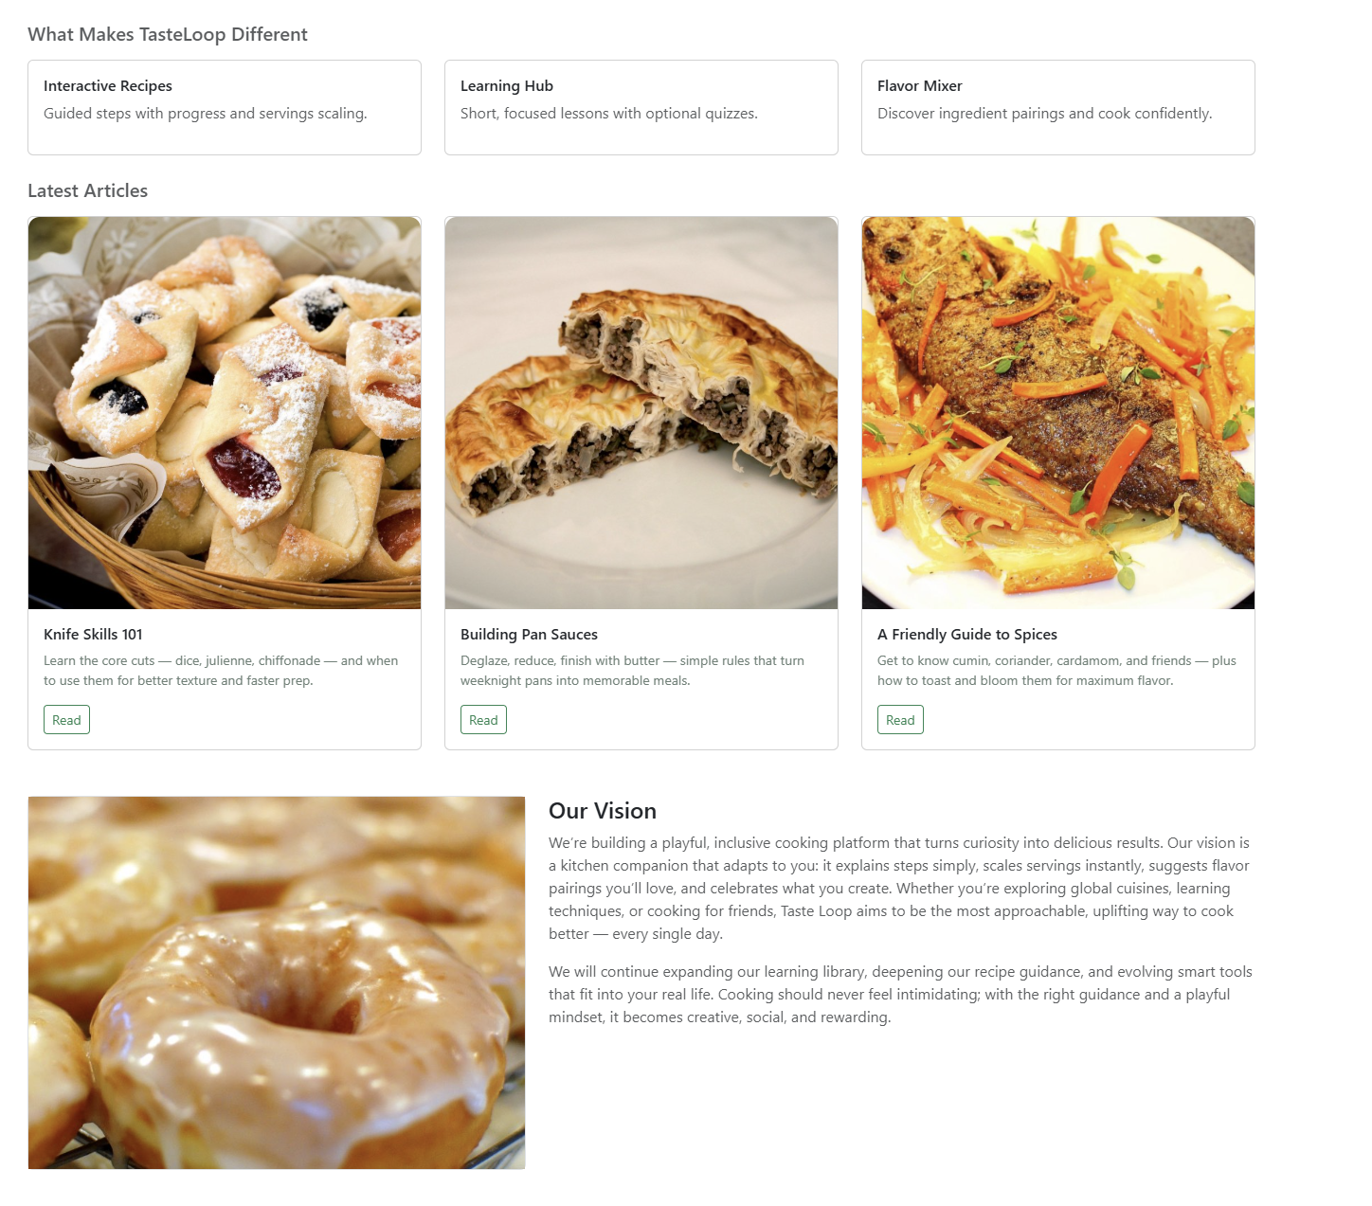

Figure 31 About Page 2

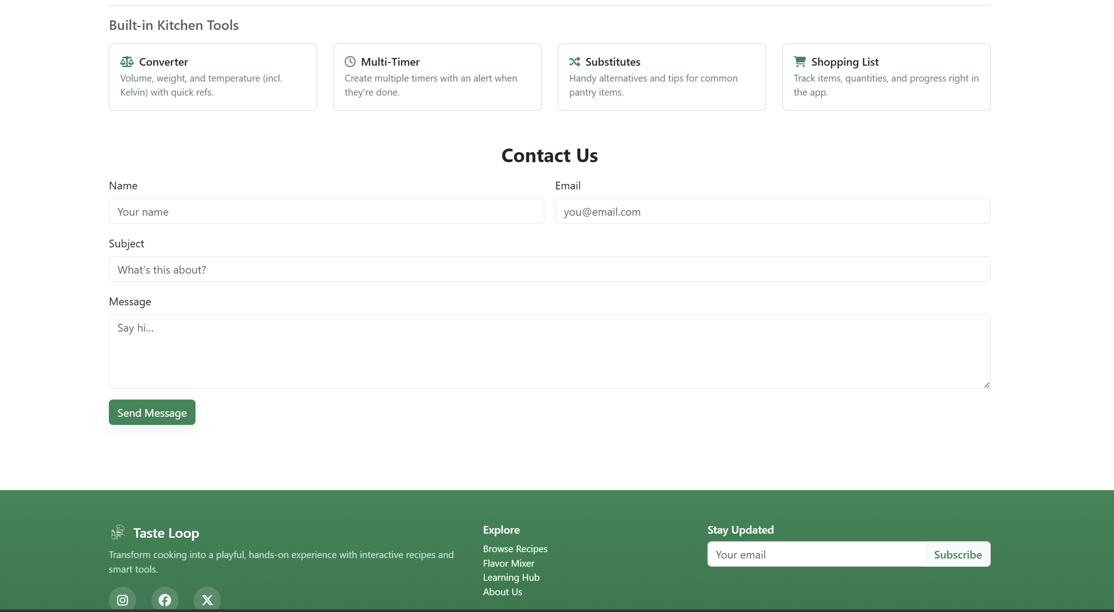

Figure 32 About Page 3

## Section 3 – Usability Testing & Evaluation

### Heuristic Evaluation

The heuristic evaluation followed the classic framework developed by Jakob Nielsen and Rolf Molich (1990) These heuristics serve as a diagnostic lens for assessing user interfaces early in development to reveal problems before formal usability testing (Nielsen, 1994). Hence, a heuristic review was conducted with five evaluators (UX lecturer, front‑end developer, UI/UX designer, culinary specialist, and

|  |  |  |  |
| --- | --- | --- | --- |
| **Evaluation Criteria** | **Marks** | Problem Identified | Name / Role |
| **1. Match system to the real world** | **Good** | The naming and categorization of recipes are intuitive and relatable, using real cooking terms that align with user expectations. | Minh Nam Tien – UX Design Specialist |
| **2. Consistency & standards** | **Need attention** | Some buttons and icons are inconsistent across pages (e.g., “Start” button color and style does not match with Floating Toolbox). | Minh Nam Tien – UX Design Specialist |
| **3. Visibility of system status & feedback** | **Need attention** | Missing loading indicators when switching recipe categories; users might not know if the system is processing. | Le Minh Hieu – UI/UX Designer |
| **4. Error prevention** | **Need attention** | No confirmation message before resetting the Portion Scaler or exiting the Flavor Mixer; users can lose data accidentally. | Le Minh Hieu – UI/UX Designer |
| **5. User sense of control & freedom** | **Need attention** | Lack of undo/redo options in the Flavor Mixer and no clear way to go back in recipe steps once started. | Tran Hoang Cuong - Culinary Specialist |
| **6. Aesthetic / minimal design** | **Good** |  | Pham Thi Huong – Cooking Blogger / Content Creator |
| **7. Recognition rather than recall** | **Good** |  |  |
| **8. Help users with errors & recovery** | **Need attention** | No clear error message appears when invalid ingredient combinations are made in the Flavor Mixer; should display contextual hints. | Tran Hoang Cuong - Culinary Specialist |
| **9. Flexibility / efficiency of use** | **Need attention** | Not very much flexible for smart phone use even though most users wants this optimization | Tran Quoc Bao – Front-End Developer |
| **10. Help & documentation** | **Good** |  | Tran Hoang Cuong - Culinary Specialist |

Figure 33 Heuristic Testing

### Usability Testing Plan.

The usability testing plan was designed to evaluate the functionality, intuitiveness, and overall user experience of the TasteLoop prototype. Each task in the plan reflects a core interaction within the system, aligned with the website’s main features such as recipe browsing, ingredient pairing, and interactive tool use. The testing scenarios were created to simulate real user behaviour, focusing on how easily participants could complete essential cooking-related actions without guidance.

|  |  |
| --- | --- |
| Task | Scenario |
| Explore the homepage, Recipes Page and recipe stacks | Users land on the homepage, browse the interactive Recipe Cards, and navigate through the arrow buttons to explore different meals. |
| Recipes Card Interaction | Users use the step-by-step recipe card modal and mark steps as completed. Users try the post review, portion scale functions and report on intuitiveness. |
| Use the Flavor Mixer Function | Users open the Flavor Mixer Page, combine ingredients or cuisines, and discover matching recipe suggestions. |
| Use the Toolbox and use integrated function: Timer, Substitute, Shopping List, Converter. | Users open the Converter or Scaler tool from the Orb Toolbox to adjust ingredient quantities or convert units (grams ↔ cups, etc.). |
| Navigate between pages (Home → Recipes → About) | Users test navigation using the navbar to ensure consistency and comprehension of the site’s structure. |
| Review The About Page | Users navigate to the about page and report on the intuitive experience + aesthetics impact of the design. User also use the contact form and report on the function operation. |
| Learning Page Interactions | Users go to the learning page, choose a dish of interest and click learn more. The user will interact with the learning card and do the quiz. |

Figure 34 Usability Test Instruction

## Section 4 – Group Activities & Co-Design

Only high-fidelity usability testing was conducted in class with the participation of fellow classmates. The activity focused on evaluating the TasteLoop prototype’s functionality, interface consistency, and interactive tools using task-based testing.

### Usability Testing Results.

|  |  |  |  |  |  |
| --- | --- | --- | --- | --- | --- |
| Aditiya Singh - 30066827 | | | | | |
| **Task** | Completion (Yes/No) | Time  (seconds) | Error  (Amount) | Satisfaction (1–5) | Comments / Observations (Bullet Points) |
| Explore the homepage, Recipes Page and recipe stacks | Yes | 15 | 1 | 5 | Intuitive layout, easy to follow |
| Recipes Card Interaction | Yes | 40 | 5 | 5 | Great attention to detail, many useful functions such as summarizing part of the recipe and serving size configuration, the card pop up for this function could be bigger so it is a bit more readable |
| Use the Flavor Mixer Function | Yes | 20 | 2 | 4 | Good feature, however some ingredients cannot be found yet |
| Use the Toolbox and use integrated function: Timer, Substitute, Shopping List, Converter. | Yes | 50 | 4 | 4 | Toolbox icon was slightly difficult to find, for the timer we should be able to see it even if the window is closed. Conversion and shopping list feature are perfect |
| Navigate between pages (Home → Recipes → About) | Yes | 30 | 1 | 5 | Simple navigation, easy point and click format. |
| Learning page Interactions | Yes | 20 | 1 | 5 | All the function works fine but there were not enough content for the prototype testing. |

Figure 35 User Testing 1

|  |  |  |  |  |  |
| --- | --- | --- | --- | --- | --- |
| **Cuong Hoang Tran -30065980** | | | | | |
| **Task** | Completion (Yes/No) | Time  (seconds) | Error  (Amount) | Satisfaction (1–5) | Comments / Observations (Bullet Points) |
| Explore the homepage, Recipes Page and recipe stacks | Yes | 10 | 1 | 5 | Intuitive layout, easy to follow |
| Recipes Card Interaction | Yes | 20 | 5 | 3 | Works like a charm!! |
| Use the Flavor Mixer Function | Yes | 5 | 2 | 3 | It works but it is a bit dull. Neutral opinion about this. |
| Use the Toolbox and use integrated function: Timer, Substitute, Shopping List, Converter. | Yes | 50 | 4 | 3 | It works. The design are dull. The function works and it is quite convenient. |
| Navigate between pages (Home → Recipes → About) | Yes | 30 | 1 | 3 | Just an about page, not a lot to say. Not a lot too say, although the design is very aesthetic. |
| Learning page Interactions | No | 30 | 2 | 3 | I did not test it because there was not enough content. |

Figure 36 User testing 2

|  |  |  |  |  |  |
| --- | --- | --- | --- | --- | --- |
| Ngo An Hieu - 30064798 | | | | | |
| **Task** | Completion (Yes/No) | Time  (seconds) | Error  (Amount) | Satisfaction (1–5) | Comments / Observations (Bullet Points) |
| Explore the homepage, Recipes Page and recipe stacks | Yes | 10 | 1 | 5 | Intuitive layout, easy to follow |
| Recipes Card Interaction | Yes | 20 | 5 | 3 | Portion scale discovered in 5; concise steps helpful; step text a bit small on mobile |
| Use the Flavor Mixer Function | Yes | 5 | 2 | 3 | Not very impressed with this page. It is just like any other page. |
| Use the Toolbox and use integrated function: Timer, Substitute, Shopping List, Converter. | Yes | 50 | 4 | 3 | Just basic function not very impressive. It works. |
| Navigate between pages (Home → Recipes → About) | Yes | 30 | 1 | 3 | Beautiful design for the page. Not very interactive though. |
| Learning page Interactions | Yes | 20 | 0 | 5 | Love this page, especially the fact that you can learn about other cultures. |

Figure 37 User testing 3

**Summary of Findings:**  
Overall, the participant successfully completed all tasks with high satisfaction scores (average = 4.7/5). The homepage and recipe browsing functions were praised for clarity and ease of use, demonstrating that the layout and navigation align well with heuristic principles of visibility and consistency. Minor issues were noted regarding card readability and ingredient database coverage. These findings informed small design adjustments, such as enlarging the modal window and improving ingredient variety for the Flavor Mixer.

## Section 5 – Prototype & Resources Description

The Tasty Loop prototype integrates several trusted external resources and libraries to ensure responsiveness, high visual quality, and diverse imagery throughout the website.

* **Bootstrap 5.3.3** — Used as the primary front-end framework, providing responsive grid utilities and layout consistency across desktop and mobile devices.
* **Font Awesome 6.5.0** — Integrated for scalable vector icons, including navigation symbols and social media logos in the footer, enhancing recognisability and accessibility.
* **Pixabay** ([pixabay.com/images/search/recipes/](https://pixabay.com/images/search/recipes/)) — Supplies free, high-resolution recipe and food imagery under the Pixabay License.
* **Pexels** ([pexels.com/search/food/](https://www.pexels.com/search/food/)) — Provides free stock photos of meals and ingredients used for recipe previews.
* **Unsplash** ([unsplash.com/s/photos/recipe](https://unsplash.com/s/photos/recipe)) — Offers open-licensed, high-quality food photography to enrich visual presentation.
* **Country Flags Repository** ([github.com/hampusborgos/country-flags](https://github.com/hampusborgos/country-flags)) — Supplies SVG flag assets used in the TasteLoop interface to represent meal origins accurately.

|  |  |
| --- | --- |
| Folder / File Path | Description |
| index.html | * Homepage introducing TasteLoop concept; * Navigation to all pages (Recipes, Flavor Mixer, Learning, About). |
| recipes.html | * Recipe browsing page with search and filters; * Interactive recipe cards with country flags; Modal with portion scaling and cooking steps; * Shopping list and ingredient substitution features. |
| flavormixer.html | * Ingredient/cuisine combination tool; * Suggests compatible ingredients and recipes; * Encourages cooking creativity and exploration. |
| learning.html | * Cooking tutorials and skill lessons; * Filter by category, difficulty, and country; Interactive quizzes with scoring; * Modal showing dish history, techniques, and fun facts. |
| about.html | * TasteLoop mission and team information; * Contact form and social media links; * Company background and values. |
| styles.css | * Main stylesheet for entire site; * Green-and-white color scheme; * Responsive design for desktop and mobile; * Custom styles for cards, buttons, modals. |
| script.js | * Core site-wide functionality; * Recipe modal with servings scaling; * Shopping list, timer, unit converter; * Rating system and newsletter validation. |
| data.js | * Contains 19 recipes in RECIPES_DATA array; * Learning tutorials in LEARNING_DATA; * Ingredient substitutes and country flags data; * Helper functions for data access. |
| learning.js | * Learning page functionality; * Quiz system with 3 questions and scoring; * Filter and display learning cards; * Modal integration with recipe details. |
| assets/ | * All images and media files — * about/: 6 images for About page; * flags/: SVG country flags (28+ countries); * recipes/: 19 recipe images; * logo.png: TasteLoop logo (44x44px); * toolbox-white.svg: Floating toolbox button icon. |

# References:

Bootstrap Team (2024) *Bootstrap v5.3.3.* Available at: <https://getbootstrap.com> (Accessed: 7 November 2025).

DataReportal (2024) *Digital 2024: Vietnam.* Available at: <https://datareportal.com/reports/digital-2024-vietnam> (Accessed: 7 November 2025).

Decision Lab (2024) *The Connected Consumer Q2 2024 – How Vietnamese are redefining their social media consumption.* Available at: <https://www.decisionlab.co/blog/how-vietnamese-are-redefining-their-social-media-consumption> (Accessed: 7 November 2025).

Font Awesome (2023) *Font Awesome 6.5.0.* Available at: <https://fontawesome.com> (Accessed: 7 November 2025).

International Organization for Standardization (ISO) (2019) *ISO 9241-210: Ergonomics of Human-System Interaction — Human-Centred Design for Interactive Systems.* Geneva: ISO.

Nielsen, J. (1994) ‘Heuristic Evaluation’, in Nielsen, J. and Mack, R.L. (eds.) *Usability Inspection Methods.* New York: John Wiley & Sons, pp. 25–62.

Norman, D.A. (2013) *The Design of Everyday Things.* Revised and expanded edition. New York: Basic Books.